Code Review: I2210181
Reviewer: James Wood
Date: April 14th, 2023
Bugs
Preventative Action/Safety
- To improve the safety and prevention of bad data, I would suggest adding a Trim() to the AddrL1 field check, and also using Len() like the other fields. This won’t prevent bad data like symbols in the address, but if a user accidentally hits space or tab or something, those mistakes are more difficult to notice.
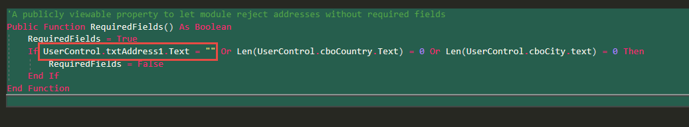
Design/Architecture (Duplication, appropriate project, namespaces, maintainability)
- Great design choice on sticking the required value check in the Address control instead of letting each module figure it out for itself.
Data Model(Naming, good design, needs index?)
Performance (Minimize DB hits, excessive loops, queries, scalable)
UI(Alignment, naming, standardization)
Error Handling(Behind events, appropriate parameter checking)
Cleanup (Dispose code, remove handlers, large data objects)
Readability (Well-named variables, methods, clear algorithm, is it understandable)
- When making properties/methods that return a Boolean, depending on the context, it typically makes the purpose clearer if it’s prefaced by an “Is…” or “Has…”. In this case, HasRequiredFields is clearer from the caller’s perspective, otherwise it could be asking what the required fields are. Obviously, you can likely intuit what it does by how it’s used and the return type, but I find it best to just make the property or method name do the work instead of relying on the dev to figure it out.
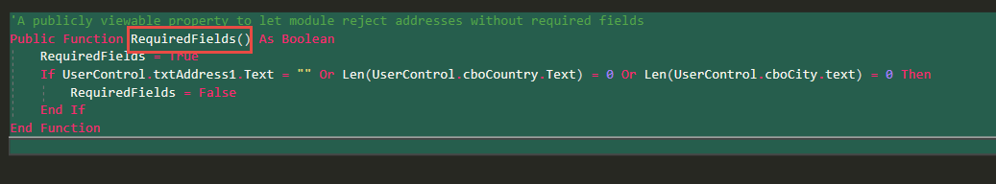
Comments (Useful, explains why rather than how)

Message Boxes (Grammar, spelling, captions, appropriate icons)
- I appreciate the commitment to consistency with the exclamation ha!
- One thing I would note here, is the message text. Instead of saying “The address must be provided!”, I think it might be clearer to say, “A valid address must be provided!”.
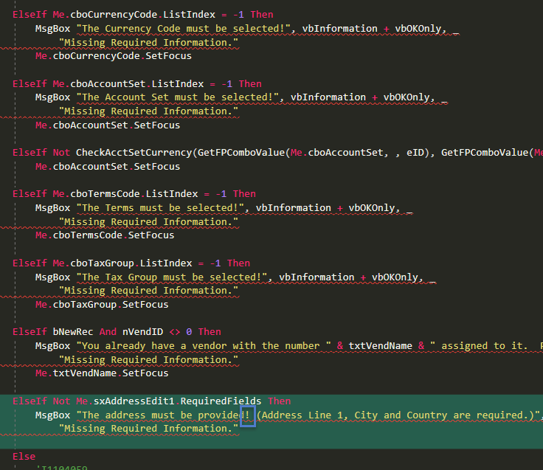
Ticket Management(Release Branch?, Testing Notes)
Extras

